**Traffic Flow Management System (TFMS)**

Traffic congestion and safety are critical challenges faced by modern cities. To address these issues, cities implement Traffic Flow Management Systems (TFMS). A TFMS is a comprehensive framework designed to optimize the movement of vehicles and pedestrians through a city's road network. It integrates various components, such as road attributes, intersection control, traffic signals, and monitoring systems, to manage traffic efficiently, reduce congestion, and enhance safety

#### **Application in Traffic Flow Management:**

1. **Traffic Monitoring and Control**: By understanding the length and speed limits of each road, the traffic management system can monitor traffic flow and implement control measures such as traffic signals and speed cameras.
2. **Route Planning and Optimization**: With detailed road attributes, route planning algorithms can suggest optimal routes for vehicles, considering factors like road length and speed limits to minimize travel time.
3. **Maintenance and Upgrades**: The system can prioritize road maintenance and upgrades based on the length and speed limits. Longer roads or those with higher speed limits may require more frequent inspections and maintenance.
4. **Emergency Response**: In case of emergencies, the system can quickly identify the fastest routes for emergency vehicles based on road length and speed limits, improving response times.
5. **Traffic Reports and Analysis**: The data can be used to generate traffic reports and conduct analysis to understand traffic patterns, identify bottlenecks, and plan for future infrastructure developments.

### 

### **ER Diagram Design Requirements:**

### **1. Entities and Attributes**

#### **Roads**

* **RoadID (PK): Unique identifier for each road.**
* **RoadName: Name of the road.**
* **Length: Length of the road in meters.**
* **SpeedLimit: Speed limit of the road in km/h.**

#### **Intersections**

* **IntersectionID (PK): Unique identifier for each intersection.**
* **IntersectionName: Name of the intersection.**
* **Latitude: Geographic latitude of the intersection.**
* **Longitude: Geographic longitude of the intersection.**

#### **Traffic Signals**

* **SignalID (PK): Unique identifier for each traffic signal.**
* **IntersectionID (FK): Identifier linking to the intersection where the signal is located.**
* **SignalType: Type of traffic signal (e.g., pedestrian, vehicle).**

#### **Traffic Data**

* **DataID (PK): Unique identifier for each traffic data record.**
* **RoadID (FK): Identifier linking to the road where the data is collected.**
* **IntersectionID (FK): Identifier linking to the intersection where the data is collected.**
* **Timestamp: Date and time of data collection.**
* **TrafficVolume: Number of vehicles passing through.**
* **AverageSpeed: Average speed of vehicles.**

### **2. Relationships**

#### **Roads and Intersections**

* **Relationship: Roads connect to Intersections.**
* **Cardinality: One-to-Many (One Road can connect to multiple Intersections, but each Intersection is at the junction of multiple Roads).**
* **Optionality: Mandatory (Each Intersection must connect to at least one Road).**

#### **Intersections and Traffic Signals**

* **Relationship: Intersections host Traffic Signals.**
* **Cardinality: One-to-Many (One Intersection can host multiple Traffic Signals, but each Traffic Signal is located at one Intersection).**
* **Optionality: Mandatory (Each Traffic Signal must be located at an Intersection).**

#### **Roads and Traffic Data**

* **Relationship: Traffic Data is collected on Roads.**
* **Cardinality: One-to-Many (One Road can have multiple Traffic Data records, but each Traffic Data record is for one Road).**
* **Optionality: Optional (Traffic Data might not be available for all Roads).**

#### **Intersections and Traffic Data**

* **Relationship: Traffic Data is collected at Intersections.**
* **Cardinality: One-to-Many (One Intersection can have multiple Traffic Data records, but each Traffic Data record is for one Intersection).**
* **Optionality: Optional (Traffic Data might not be available for all Intersections).**

### **3. Normalization Considerations**

#### **First Normal Form (1NF)**

* **Ensure that each attribute contains only atomic (indivisible) values.**
* **Example: In the Traffic Data entity, TrafficVolume and AverageSpeed are atomic values.**

#### **Second Normal Form (2NF)**

* **Ensure that all non-key attributes are fully functional dependent on the primary key.**
* **Example: In the Traffic Signals entity, IntersectionID is a foreign key, and SignalType is fully dependent on SignalID.**

#### **Third Normal Form (3NF)**

* **Ensure that all attributes are only dependent on the primary key and not on other non-key attributes.**
* **Example: In the Intersections entity, IntersectionName, Latitude, and Longitude are dependent only on IntersectionID.**
* **ID in Traffic Signals)**
* **Roads (1) - (M) Traffic Data (RoadID in Traffic Data)**

**Tasks :**

**Task 1 :**

#### 1. Roads

Attributes:

* RoadID (PK): Unique identifier for each road.
* RoadName: Name of the road.
* Length: Length of the road in meters.
* SpeedLimit: Speed limit of the road in kilometers per hour (km/h).

#### 2. Intersections

Attributes:

* IntersectionID (PK): Unique identifier for each intersection.
* IntersectionName: Name of the intersection.
* Latitude: Geographic latitude of the intersection.
* Longitude: Geographic longitude of the intersection.

#### 3. Traffic Signals

Attributes:

* SignalID (PK): Unique identifier for each traffic signal.
* IntersectionID (FK): Identifier linking to the intersection where the signal is located.
* SignalType: Type of traffic signal (e.g., pedestrian, vehicle).

#### 4. Traffic Data

Attributes:

* DataID (PK): Unique identifier for each traffic data record.
* RoadID (FK): Identifier linking to the road where the data is collected.
* IntersectionID (FK): Identifier linking to the intersection where the data is collected.
* Timestamp: Date and time of data collection.
* TrafficVolume: Number of vehicles passing through.
* AverageSpeed: Average speed of vehicles.

**Task 2 :**

### Relationship Modeling

#### ER Diagram Overview

1. Roads connect to Intersections.
2. Intersections host Traffic Signals.
3. Roads and Intersections are associated with Traffic Data.

### Relationships and Cardinality

#### 1. Roads to Intersections

* Relationship: Roads connect to Intersections.
* Cardinality: One-to-Many (One Road can connect to multiple Intersections, but each Intersection connects to multiple Roads).
* Optionality: Mandatory (Each Intersection must connect to at least one Road).

#### 2. Intersections to Traffic Signals

* Relationship: Intersections host Traffic Signals.
* Cardinality: One-to-Many (One Intersection can host multiple Traffic Signals, but each Traffic Signal is located at one Intersection).
* Optionality: Mandatory (Each Traffic Signal must be located at an Intersection).

#### 3. Roads to Traffic Data

* Relationship: Traffic Data is collected on Roads.
* Cardinality: One-to-Many (One Road can have multiple Traffic Data records, but each Traffic Data record is for one Road).
* Optionality: Optional (Traffic Data might not be available for all Roads).

#### 4. Intersections to Traffic Data

* Relationship: Traffic Data is collected at Intersections.
* Cardinality: One-to-Many (One Intersection can have multiple Traffic Data records, but each Traffic Data record is for one Intersection).
* **Optionality: Optional (Traffic Data might not be available for all Intersections).**

**Task 3 : ER Diagram Design**

+-----------------------+

| Roads |

+-----------------------+

| RoadID (PK) |

| RoadName |

| Length |

| SpeedLimit |

+-----------------------+

|

| (1,M)

|

+-----------------------+

| Intersections |

+-----------------------+

| IntersectionID (PK) |

| IntersectionName |

| Latitude |

| Longitude |

| RoadID (FK) |

+-----------------------+

|

| (1,M)

|

+-----------------------+

| Traffic Signals |

+-----------------------+

| SignalID (PK) |

| IntersectionID (FK) |

| SignalType |

+-----------------------+

|

| (1,M)

|

+-----------------------+

| Traffic Data |

+-----------------------+

| DataID (PK) |

| RoadID (FK) |

| IntersectionID (FK) |

| Timestamp |

| TrafficVolume |

| AverageSpeed |

+-----------------------+

**EXAMPLE ER DAIGRAM: (TFMS)**

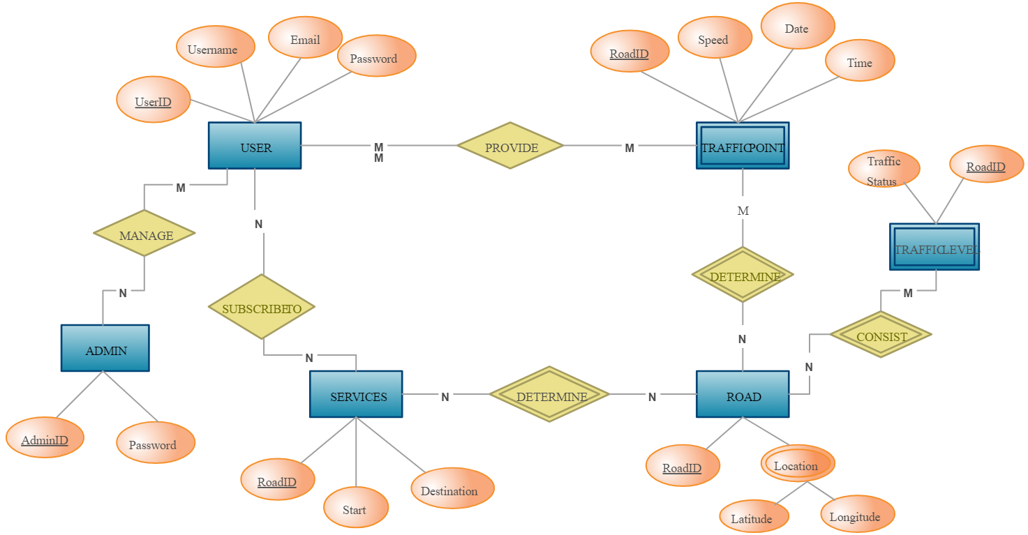

**TASK 4:**

### **Justification and Normalization:**

#### **Design Choices Justification**

1. **Entity Selection**:
   * **Roads**, **Intersections**, **Traffic Signals**, and **Traffic Data** are fundamental entities in traffic flow management systems. They cover essential aspects such as road attributes, intersection control, signal management, and traffic monitoring.
2. **Relationships**:
   * **Roads connect to Intersections** to simulate real-world traffic flow patterns where roads meet at intersections.
   * **Intersections host Traffic Signals** to manage and control traffic flow efficiently at critical points.
   * **Traffic Data** is collected on both Roads and Intersections to monitor traffic volume, speed, and other metrics crucial for real-time decision-making.
3. **Normalization**:
   * **1NF (First Normal Form)**: Ensures atomicity by ensuring each attribute contains only a single value. For example, attributes like TrafficVolume and AverageSpeed in Traffic Data are atomic.
   * **2NF (Second Normal Form)**: Ensures all non-key attributes are fully dependent on the primary key. Attributes like SignalType in Traffic Signals depend fully on the SignalID.
   * **3NF (Third Normal Form)**: Ensures all attributes are directly dependent on the primary key, and no transitive dependencies exist. For example, in Roads and Intersections, attributes like RoadName, Length, Latitude, and Longitude are directly dependent on the primary keys (RoadID and IntersectionID, respectively).

### **Considerations for Scalability, Real-time Data Processing, and Efficiency**

1. **Scalability**:
   * **Database Design**: Use of proper indexing on primary and foreign keys, partitioning data across multiple servers (sharding), and considering horizontal scaling techniques can enhance scalability.
   * **Traffic Data Storage**: Efficient data storage techniques (e.g., time-series databases for real-time data) can manage large volumes of traffic data.
2. **Real-time Data Processing**:
   * **Data Collection**: Implementing data collection mechanisms (e.g., IoT sensors, real-time APIs) to gather traffic data continuously.
   * **Streaming Data**: Use of stream processing frameworks (e.g., Apache Kafka, Apache Flink) to process and analyze real-time traffic data for immediate insights.
3. **Efficient Traffic Management**:
   * **Traffic Signal Optimization**: Algorithms to dynamically adjust traffic signal timings based on real-time traffic conditions (e.g., traffic volume, congestion).
   * **Route Planning**: Integration with navigation systems to provide real-time traffic updates and suggest optimal routes to minimize congestion.

### **Ensuring Normalization (1NF, 2NF, 3NF)**

1. **1NF (First Normal Form)**:
   * Ensure each attribute in every table contains atomic values.
   * Example: Ensure Traffic Data attributes like TrafficVolume and AverageSpeed contain single values, not arrays or lists.
2. **2NF (Second Normal Form)**:
   * Ensure all attributes are fully dependent on the primary key.
   * Example: Traffic Signals table should have SignalType fully dependent on SignalID, without partial dependencies on other attributes.
3. **3NF (Third Normal Form)**:
   * Eliminate transitive dependencies where an attribute depends on another non-key attribute.
   * Example: Ensure attributes like RoadName and SpeedLimit in Roads depend directly on RoadID, not on each other.

### **Conclusion**

By adhering to these design choices and normalization principles, the ER diagram for the Traffic Flow Management System ensures efficient data storage, scalable operations, real-time data processing capabilities, and improved data integrity. This approach supports effective traffic management by enabling quick decision-making based on accurate and up-to-date traffic information.